

Contract Awards

**Optimization Techniques and Applications**

Submitted to: Dr. Vibhor Kant and Dr. Jayprakash Kar

**Group G-23**

1. Tanishq Goel (17ucs164) 2.) Ronak Mangal (18ucs006)

3.) Yash Agarwal (18ucs014) 4.) Ronak Toshniwal (18ucs059)

5.) Arpit Jain (18ucs085) 6.) Vani Agarwal (18ucs098)

7.) Amay Sharma (18ucs108)



**Overview**

Award contracts to suppliers who have bid certain prices to supply products to facilities in several states – allow for bids specifying a minimum size for each state.

**Problem Statement**

A food preserving company has 2 different canning factories. Certain growers are willing to provide fresh vegetables to this canning company in the following amounts:

Grower 1 (G1): 300 tonnes at 1100 rupees/tonne

Grower 2 (G2): 410 tonnes at 1000 rupees/tonne

Grower 3 (G3): 520 tonnes at 1300 rupees/tonne

Capacities of the factories i.e. the amount of fresh vegetables that by be canned by them in any given week is:

Factory A: 560 tonnes

Factory B: 660 tonnes

There is a certain minimum amount for both the factories that company had to buy to ensure that both factories are working properly that is:

Factory A: 300 tonnes

Factory B: 350 tonnes

Cost of shipping (in rupees) the fresh vegetables per tonne by the growers to the canning company:

|  |  |  |
| --- | --- | --- |
|  | Factory A | Factory B |
| Grower 1: | 400 | 450 |
| Grower 2: | 300 | 350 |
| Grower 3: | 600 | 500 |

Cost of labour in canning these vegetables in both the factories is like:

Factory A: 2600 rupees/tonne

Factory B: 1900 rupees/tonne



Company will sell these canned vegetables at 5100 Rs/tonne whatever quantity they canned.

Now based on the above information various models are possible:

1. We can maximise the total revenue earned by the canning company by selling canned vegetables at 5100 Rs/tonne.
2. We can minimize the grower supply cost which varied among different growers.
3. We can minimise the transportation cost which includes cost to take fresh vegetables from growers to factory.
4. We can minimise the cost of labours who are involve in canning these vegetables.
5. Now most important thing is to maximise the profit using above models.



**Assumptions and Formulation**

**The basic assumptions are:**

1. can ship from a grower any quantity we desire

2. no loss in weight in processing at the factory

3. no loss in weight in shipping

4. can sell all we produce

5. all the data/numbers given are accurate

**Variables: -**

We need to decide how much to supply to these two canning factories from each of the three growers.

Hence, let the number of tonnes supplied to each of the two canning factories by each of the growers to be denoted by the following variables:

|  |  |  |
| --- | --- | --- |
|  | **Factory A** | **Factory B** |
| **Grower 1** | X1 | Y1 |
| **Grower 2** | X2 | Y2 |
| **Grower 3** | X3 | Y3 |

**Constraints: -**

Since, the tonnes of fresh vegetables supplied by any of the growers cannot be negative so

Non- negativity constraint: X1, X2, X3, Y1, Y2, Y3 ≥ 0

Also, a grower cannot supply more than he has available, so supply constraints are also there so,

X1 + Y1 ≤ 300

X2 + Y2 ≤ 410

X3 + Y3 ≤ 520



Factories cannot process fresh vegetables more than their capacity i.e. the capacity of each factory is also restricted so:

Capacity constraints:

X1 + X2 + X3 ≤ 560

Y1 + Y2 + Y3 ≤ 660

Factories should process some minimum amount of fresh vegetables i.e.

X1 + X2 + X3 ≥ 300

Y1 + Y2 + Y3 ≥ 350

NOTE: We will use **Linear Programming** to maximise or minimise the objective as all the constraints and equation include linear functions only and the output may or may not be integer that’s why we are not using **Integer Linear Programming**.



Model 1: Maximise the total revenue

**Objective Function:** Z = 5100*(X1 + X2 + X3 + Y1 + Y2 + Y3)

**Solution:**

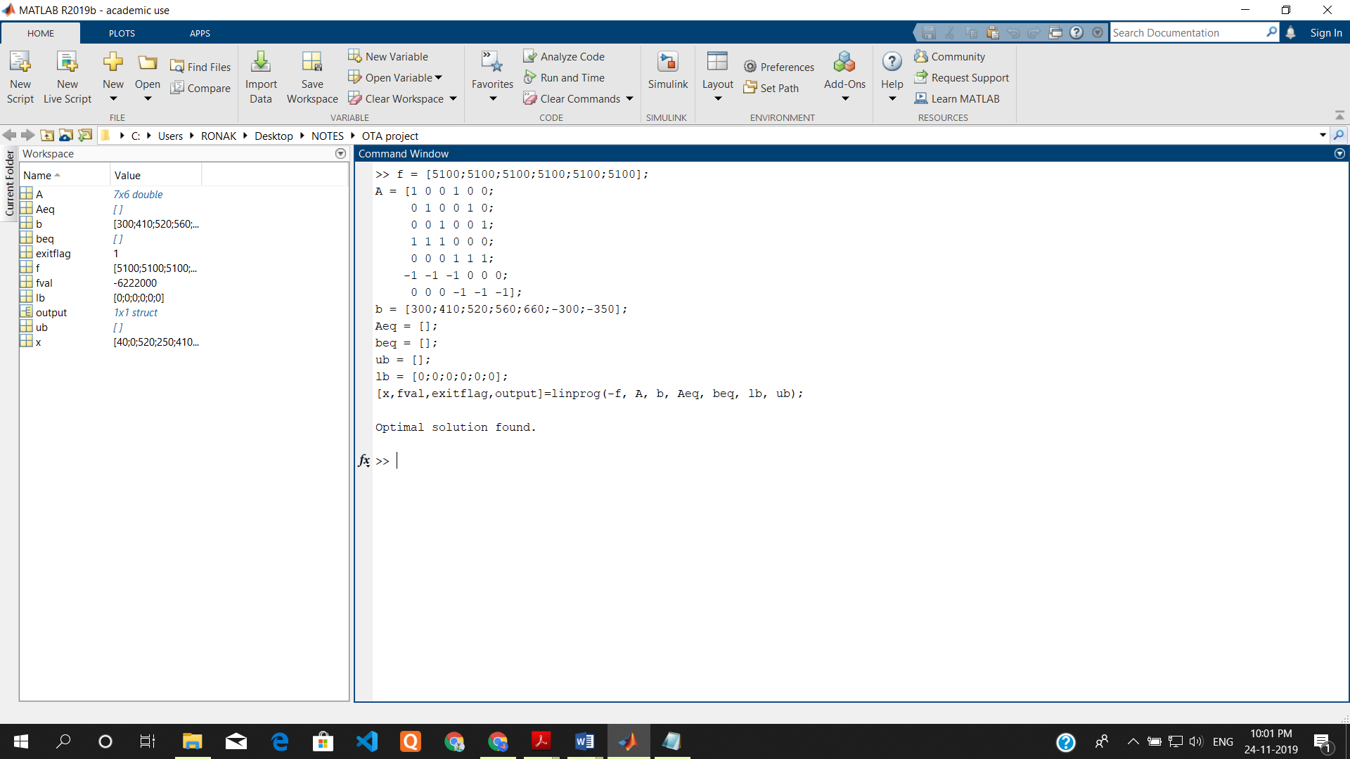

Linprog minimizes the function by default therefore in this model we passed -f in linprog.

Therefore, optimal objective value will be the | fval | i.e. 6222000.

**The MATLAB code for this objective function is:**

PFA: **Model1.m**

LP: Optimal objective value is 6222000.

**Optimal Solution:**

X1 = 40 X2 = 0 X3 = 520

Y1 = 250 Y2 = 410 Y3 = 0



Model 2: Minimize the grower supply cost

**Objective Function:** Z = 300*X1 + 410*X2 + 520*X3 + 300*Y1 + 410*Y2 + 520*Y3

**Solution:**

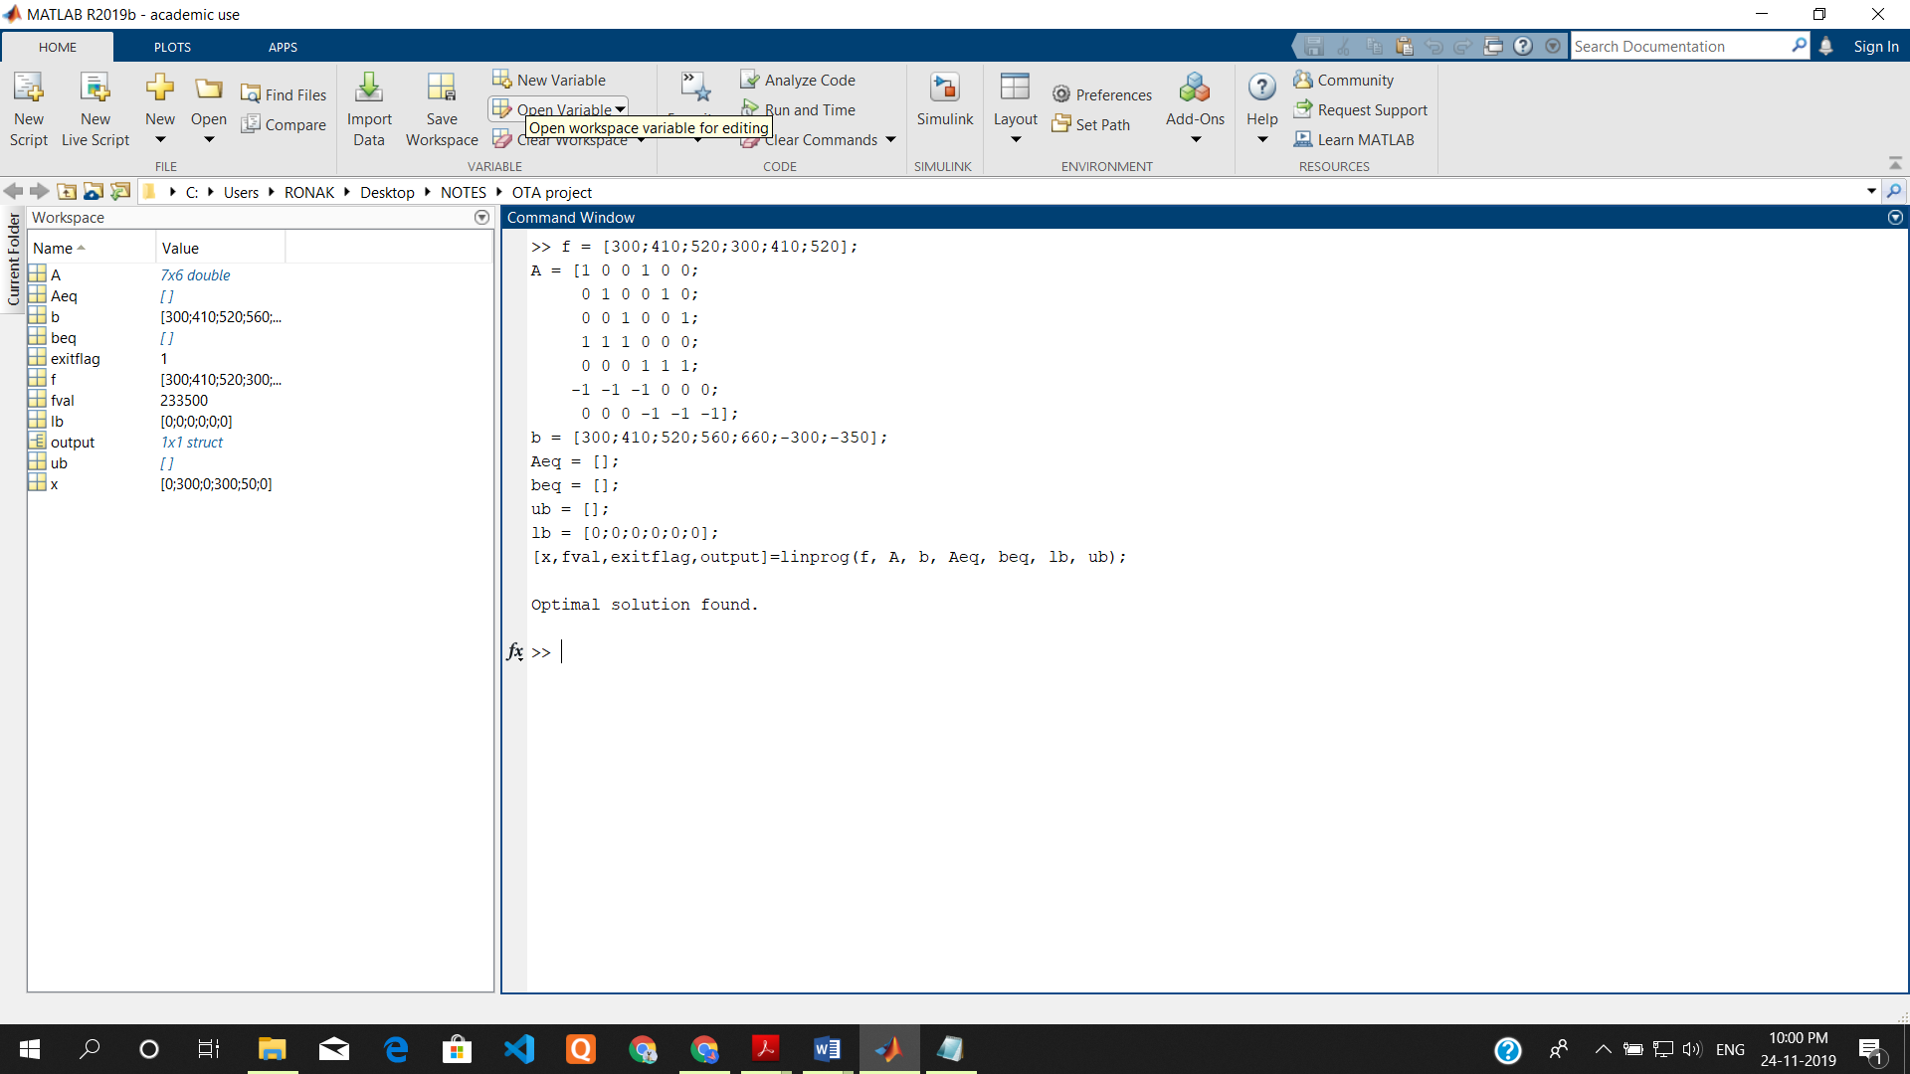

**The MATLAB code for this objective function is:**

PFA: **Model2.m**

LP: Optimal objective value is 233500.

**Optimal Solution:**

X1 = 0 X2 = 300 X3 = 0

Y1 = 300 Y2 = 50 Y3 = 0



Model 3: Minimize the transportation cost

**Objective Function:** Z = 400*X1 + 300*X2 + 600*X3 + 450*Y1 + 350*Y2 + 500*Y3

**Solution:**

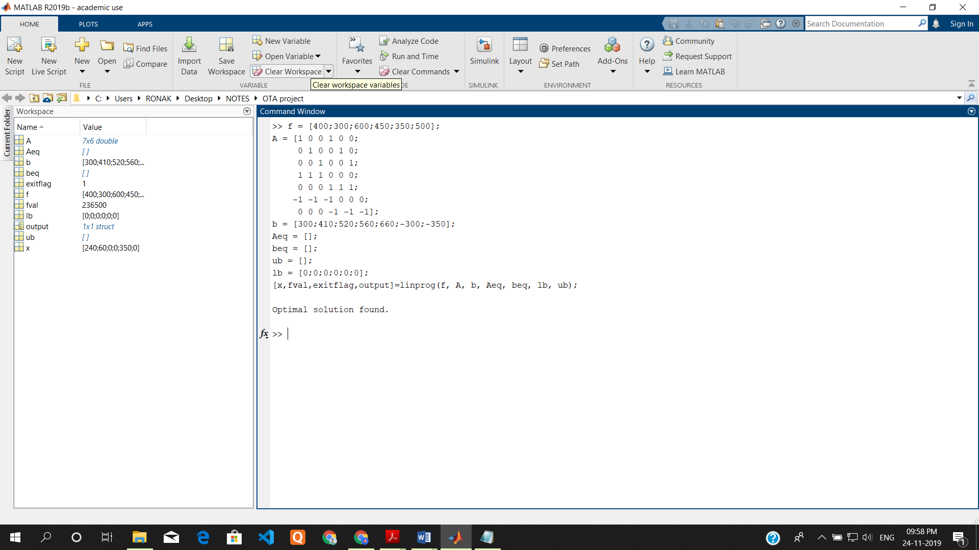

**The MATLAB code for this objective function is:**

PFA: **Model3.m**

LP: Optimal objective value is 236500.

**Optimal Solution:**

X1 = 240 X2 = 60 X3 = 0

Y1 = 0 Y2 = 350 Y3 = 0



Model 4: Minimize the cost of labours

**Objective Function:** Z = 2600*(X1 + X2 + X3) + 1900*(Y1 + Y2 + Y3)

**Solution:**

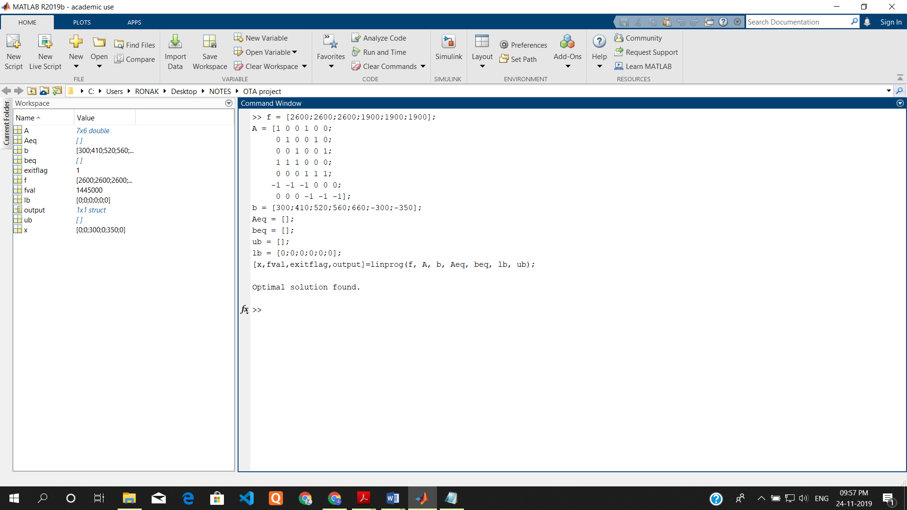

**The MATLAB code for this objective function is:**

PFA: **Model4.m**

LP: Optimal objective value is 1445000.

**Optimal Solution:**

X1 = 0 X2 = 0 X3 = 300

Y1 = 0 Y2 = 350 Y3 = 0



Model 5: Maximise the total profit

To maximise total profit, we have to maximise revenue, minimize grower supply cost, minimize grower shipping cost, minimize factory labour cost.

To maximize revenue, we will have to maximize the following equation:

A= 5100*(X1 + X2 + X3 + Y1 + Y2 + Y3) --------(i)

To minimize grower supply cost, we will have to maximize the following equation:

B = -300 (X1+ Y1) - 410(X2 + Y2) - 520(X3 + Y3) ---------(ii)

To minimize grower shipping cost, we will have to maximize the following equation:

C= -400X1 – 450Y1 – 300X2 – 350Y2 – 600X3 – 500Y3 ---------(iii)

To minimize factory labour cost, we will have to maximize the following equation:

Assuming the minimum grower supply cost to be D

D= -2600(X1 + X2 + X3) - 1600(Y1 + Y2 + Y3) ----------(iv)

Summing up the above 4 maximizing equations (i.e. (i), (ii), (iii), (iv))

Z = A+B+C+D = 5100(X1 + X2 + X3 + Y1 + Y2 + Y3) -300 (X1+ Y1) - 410(X2 + Y2) - 520(X3 + Y3) -400X1 – 450Y1 – 300X2 – 350Y2 – 600X3 – 500Y3 -2600(X1 + X2 + X3) - 1600(Y1 + Y2 + Y3)

**Objective Function:** Z = 1800*X1 + 1790*X2 + 1380*X3 + 2450*Y1 + 2490*Y2 + 2180*Y3

**Solution:**

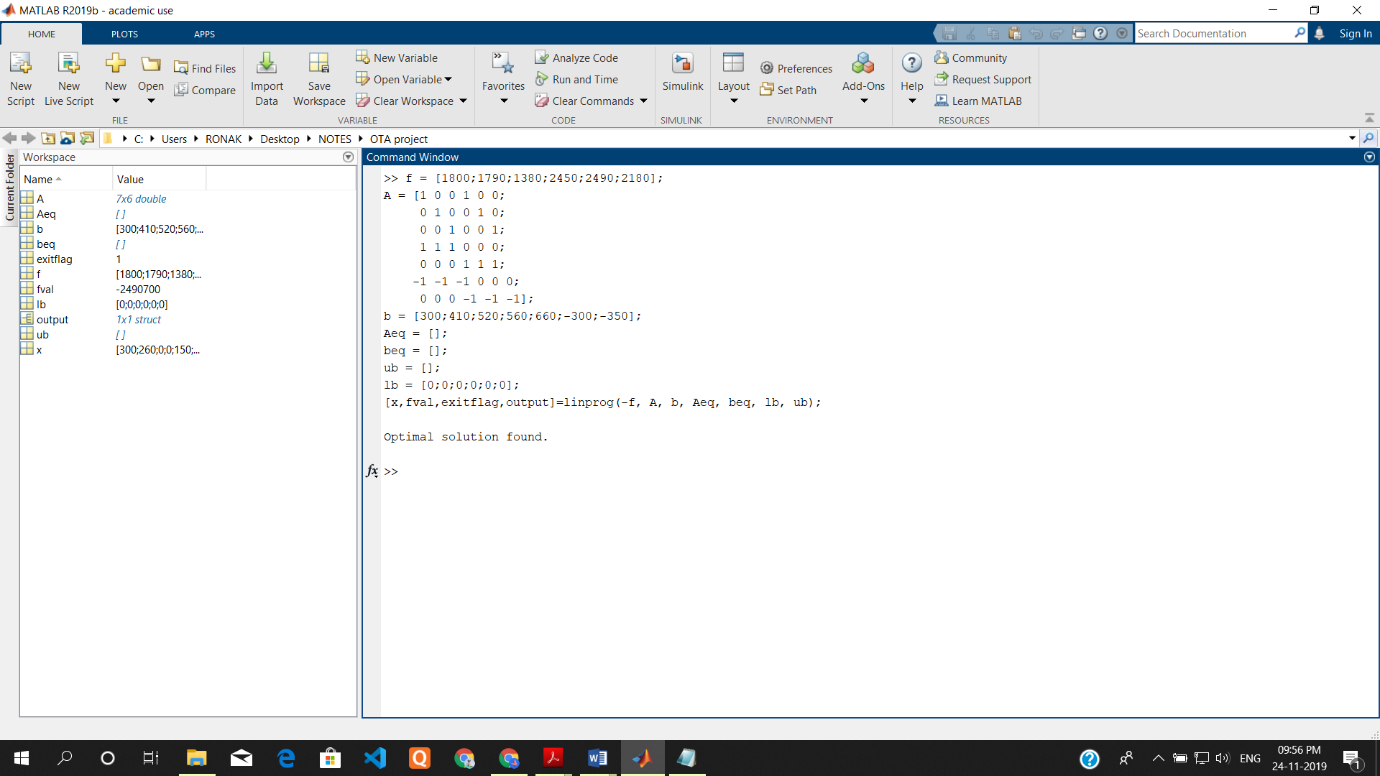

Linprog minimizes the function by default therefore in this model we passed -f in linprog.

Therefore, optimal objective value will be the | fval | i.e. 2490700.



**The MATLAB code for this objective function is:**

PFA: **Model5.m**

LP: Optimal objective value is 2490700.

**Optimal Solution:**

X1 = 300 X2 = 260 X3 = 0

Y1 = 0 Y2 = 150 Y3 = 510



# Conclusion

With the help of MATLAB and Optimization Techniques, we were able to optimize the various factors in the process of awarding the contracts to the growers.